QUESTION 1 – BANKING CRISES (maximum 800 words) – [25 points]

1. Discuss the recent banking crisis in the US (SVB, First Signature and First Republic and related events). In particular address the following issues:
2. Solvency versus liquidity – which was the problem (illustrate with a diagram on balance sheet) – [5 points]
3. Origin of the crisis [3 points]
4. Contagion – (i) how did it happen and what made it worse, (ii) when is bail-out of depositors justified (discuss critically)? [6 points]
5. Prudential tools [4 points]
6. Crisis management tools and the role of different agencies [7 points]

Solvency stands for a bank’s capability of meeting its long-term obligations, and liquidity is the bank’s ability to timely meet its short-term obligations. However, these two terms are often interconnected, and this can be demonstrated by the diagram in our lecture slides:

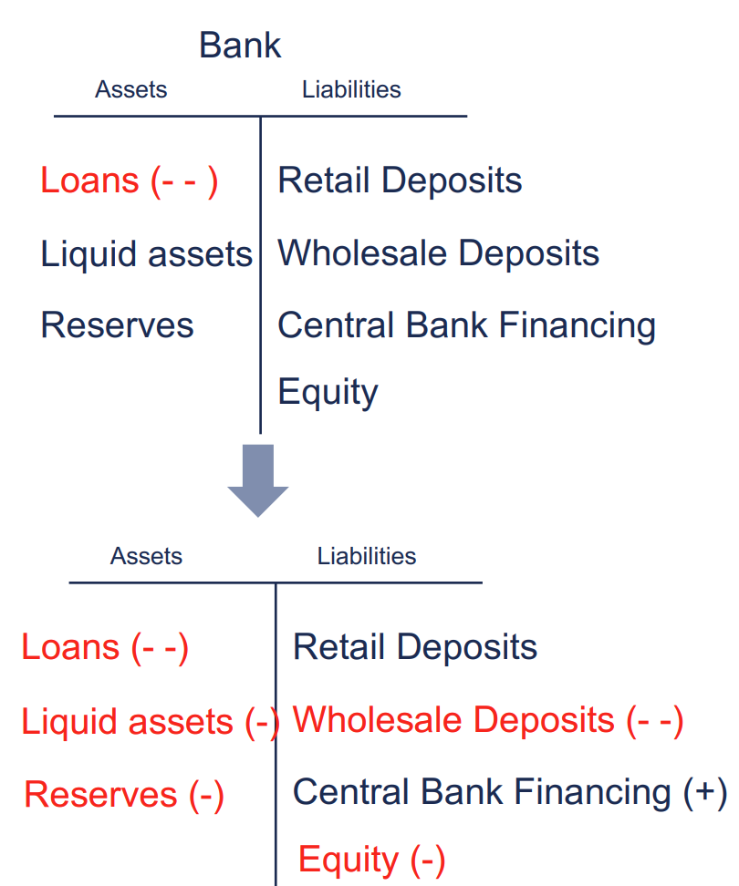

Usually, depositors will start to withdraw their deposits under the worry that this bank may face solvency problems, that its financial assets may not be able to cover its obligations, leading to a negative equity. Then, the bank will be facing liquidity problems in the short term, as it may have to sell part of its financial assets to return money to depositors. A likely result is that these financial assets will be subject to a significant amount of impairment, or the highly liquid assets are not enough to cover the withdrawal amount, causing a banking crisis. Oftentimes, if there is no such a large withdrawal, the bank will not end up being insolvent. So the trigger of the problem is the worry of insolvency, but what actually happened first is illiquidity.

In the case of SVB, the origin of the crisis is similar. SVB is special because its main clients are Silicon Valley start-ups and VCs. 2020 and 2021 were great years for these companies because the liquidity injection provided by the government and the Fed, so the deposits in SVB increased a lot as well. Coming to 2023, SVB depositors start to worry about the bank facing high number of withdrawals as the market started to cool down in 2022, and there might be liquidity and eventually solvency problems. The continuing massive withdrawals due to the market panic forced SVB to sell its assets including some government bonds and MBS that were intended to be held until maturity. Because the rate had hiked 4.5% since March 2022, the sale of HTM securities incurred significant loss for SVB. In the end, the bank depleted its capital and failed.

Contagion refers to a financial crisis of a company/market spreading to other related entities/markets, which is what happed in the banking crisis in March. After the failure of SVB, people started to actively seek for other banks that might suffer the same problem, and their target became First Signature and First Republic, and eventually Credit Suisse. The market knew that these banks can probably survive if there were no such big withdrawals/selloffs, but I think the fail of SVB reminded the public that market panic could easily destruct a top 25 bank. The fact that there was no clear protection beyond $250000 from FDIC at that time exacerbated the bank run.

Bail-out can trigger a lot of debates because it is spending tax-payers money to save a dead bank. But it can be justified when the crisis will spread to a much wider market if no actions were taken, just like the subsequent bankruptcy of these regional banks. However, one can also argue that bail-out can make the banks be less risk-averse, knowing that they can be covered in the end, which harms depositors’ financial security.

Prudential tools are regulations that can help ensure the stability of the entire banking system. Some prudential tools can be increasing the capital reserve ratio of banks, forcing smaller banks like SVB to go through stress tests and use stricter criteria like large banks, adding more extreme scenarios in the risk simulations.

Agencies such as the Fed and FDIC should be in charge of managing these types of crises. The Fed can provide liquidity for banks such as lending temporarily to these banks at a discounted rate. And FDIC can bail out the deposits to avoid further market panicking.

QUESTION 2- CENTRAL BANKING (maximum 800 words) – [35 points]

Discuss tradeoff between price stability and financial stability when tightening monetary policy. Chose either the ECB, the Bank of England or the Federal Reserve to illustrate the case with relevant data for the recent tightening cycle.

In answering the question:

1. Explain the transmission mechanism for QT and short-term interest rate increase and report relevant numbers for the case of your choice in recent tightening cycle
2. Give a view on tradeoffs for both instruments and evaluate those risks for the case of your choice in recent tightening cycle
3. Explain how the two objectives must be balanced

Quantitative tightening is to reduce central bank’s balance sheet by not reinvesting the proceeds as Treasuries and MBS mature. Take the example of Fed, it started QT in June 2022 after ending QE in March. Every month, the Fed stopped reinvesting $30 Billion of Treasuries and $17.5 Billion of MBS, later in September it become $60 and $35 billion. As a result, these assets were reduced from the Fed’s balance sheet.

Another tool that the Fed uses to maintain stable prices is to raise fed fund rate, and this is implemented through open market operations. When the Fed want to raise the rate, it would sell treasuries to banks, so that there is less liquidity in the fed funds market, causing the interest to rise. Since March 2022, the Fed has hiked fed fund rate from 0.25% to 5.25%, and is expected to halt rate hikes in the next June FOMC meeting at a possibility of 77% according to CME Fed Watch.

In general, QT and rate hikes will lower the inflation at the expense of weaken the economy as pulling away liquidity from the market. This can be beneficial under an overheated economy with high inflation. However, the recent tightening cycle is quite different because we have been in a stagflation, meaning that the inflation is high but the economy growth is not great either. This presents more difficulty for the Fed to maintain the balance of price stability and financial stability, because the risk of forcing the economy into a recession while lowering inflation is very significant. It took time for the rate hikes to actually make impact to consumer prices, but the economy can weaken before the price has been brought down.

The recent inflation data in May is slightly above the market expectation, with core CPI on par at 5.5%, and core PCE YoY at 4.7% higher than the 4.6% consensus. But overall CPI this year is said to be under control, so it is critical for the Fed to decide the next steps.

The balance of price stability and financial stability is important because the essential goal of the Fed is to promote the overall health of the US economy, and achieving price and financial stability can foster sustainable economic growth instead of boom-and-bust cycles that are harmful to the long-term growth of the economy.

Question 3 [20 points]

3.1 Do you agree with Milton Friedman that the social responsibility of a financial institution is to maximise long-term profits? (10 points)

I do not agree with Milton Friedman. This can be argued from the perspectives of both governmental financial agencies and commercial financial institutions. First of all, the goal of governmental financial agencies such as Central Banks should never be maximising profits, because the purpose of a country is essentially maintaining a sustainable economy with national peace and prosperity. As for commercial financial institutions, if the company is solely focusing on maximising long-term profits, it may do businesses with negative externalities that are harmful to the overall financial health of a nation, such as arbitrarily granting housing loans before the global financial crisis. There are various kinds of stakeholders when the company engages in its business, such as governments, customers, competitors, employees, etc. Long-term profits will be naturally generated if the financial institution seeks to maximize the total welfare of these stakeholders, instead of taking long-term financial profits as the major goal. This is an effective way for us to try to avoid experiencing crises like in 2008.

3.2 Why might it be legitimate for a sustainable fund to own an oil and gas company? (10 points)

It can be legitimate because a sustainable fund can own an oil and gas company for a good purpose. If the oil and gas company is a pioneer in limiting negative environmental impacts within oil and gas industry, it can be a beneficial move to invest in this company, because in places that use oil and gas to produce energy, it is good to have a cleaner option before switching to innovative green energy sources. The same goes for oil and gas company that is actively switching towards green energy.

It can also be that this sustainable fund is doing impact investing, hoping to pivot the company’s operating strategy to more sustainable businesses after holding a big enough stake to impact the company’s operation.

Question 4 [20 points]

Write a short essay (500 words) on the impact of the growth of AMs and Fintech on commercial banks' franchise value/profitability.

* In your essay refer to the following graph which represents the significant collapse in commercial bank deposits following the recent US monetary policy tightening and the US regional bank failures and the corresponding inflows into retail money market funds.

Commercial banks historically were the most popular platforms for people to store their wealth. However, as AMs and Fintech companies continued to expand through innovations in all aspects of their businesses including portfolio management, client interactions, and product offerings, they quickly attract people’s attention and prompt them to move their assets from traditional commercial banks.

According to the first chart, the total deposits in commercial banks had experienced a steady decline from 2013 to 2019, marking the loss of attractiveness to depositors. We see a significant spike in 2020, but this is mainly due to the covid relief package from former president Trump, that let citizens directly receive payment to their bank account. The later dramatic plunge shows that people still move out their deposits to some where else.

A lot of these funds were transferred to AMs and fintech companies, as illustrated by the second chart that shows opposite trends between commercial banks deposits and retail money market funds. AMs have advantage over commercial banks that their incentives are aligned with investors, which is to maximize their return. On the other hand, bank often seeks to maximize profit only for shareholders, sometimes at the expense of the returns of depositors, as the returns of deposits are simply barely enough to let clients deposit their money, whereas investing portfolios of asset managers have theoretically unlimited upside.

The most essential advantage of commercial banks is that the return of deposits is safe and stable, while investing products of AMs and fintech exposes investors to a series of credit and market risks. This landscape began to shift as the failure of multiple commercial banks and the innovation of money market funds that serves as direct competitor to bank deposits that also offer safe returns.

The decline in total deposits affects commercial banks in many ways. An important one is that it limits the activities at the bank’s liability side, which are the main sources of profits such as all kinds of lending activities. A sudden drop in deposits also makes the banks riskier by stimulating bank runs, as demonstrated by the SVB crisis this year. These banking crises created a vicious cycle that steers depositors away from investing their wealth in commercial banks.

Nowadays, many banks are actively seeking for transformations to fintech and emphasis on asset management businesses. With increasing investments in technology and innovation, some commercial banks are now well positioned to confront the new competition from AMs and Fintech and prepare to upgrade its businesses to best accommodate the current market developments.